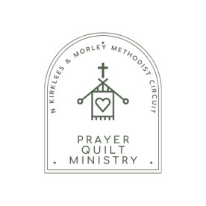North Kirklees & Morley Circuit

Prayer Quilt Ministry

By completing this form, the nominee is agreeing to have a prayer quilt created for them.

During the creation of the quilt, prayers will be said in the name of the recipient.

In order for us to make your quilt please could you complete the details below?

|  |  |
| --- | --- |
| Name (for quilt): |  |
| Church attended: |  |
| Reason for quilt:  (e.g. long-term illness, housebound, recovery from operation, forthcoming operation, bereavement etc) |  |
| Requested from: |  |
| Contact Email or Number (for the person requesting the quilt): |  |

Once completed please return via email to tingleymc@gmail.com or send to Prayer Quilts, c/o Tingley Methodist Church, Westerton Road, Tingley, Wakefield. WF3 1AF